**Daily Scrum or Standup Meeting**

Team name: Group 8_________________________

Scrum Master: Cole_______________________

Date: 3-24_______________________________

|  |  |  |  |
| --- | --- | --- | --- |
| **Team Member** | **What did you do since the last scrum?** | **What do you plan to do before the next scrum?** | **What obstacles do you have?** |
| Austin | Implemented the APIs into the customer client | Get ready for demo, clean code | None |
| Cole | Started getting the lot admin pages into Django | Continue working on lot admin | Time |
| Logan | N/A | N/A | Time |
| Jeremy | Refined APIs | Unclear | Time |
|  |  |  |  |

# Burndown

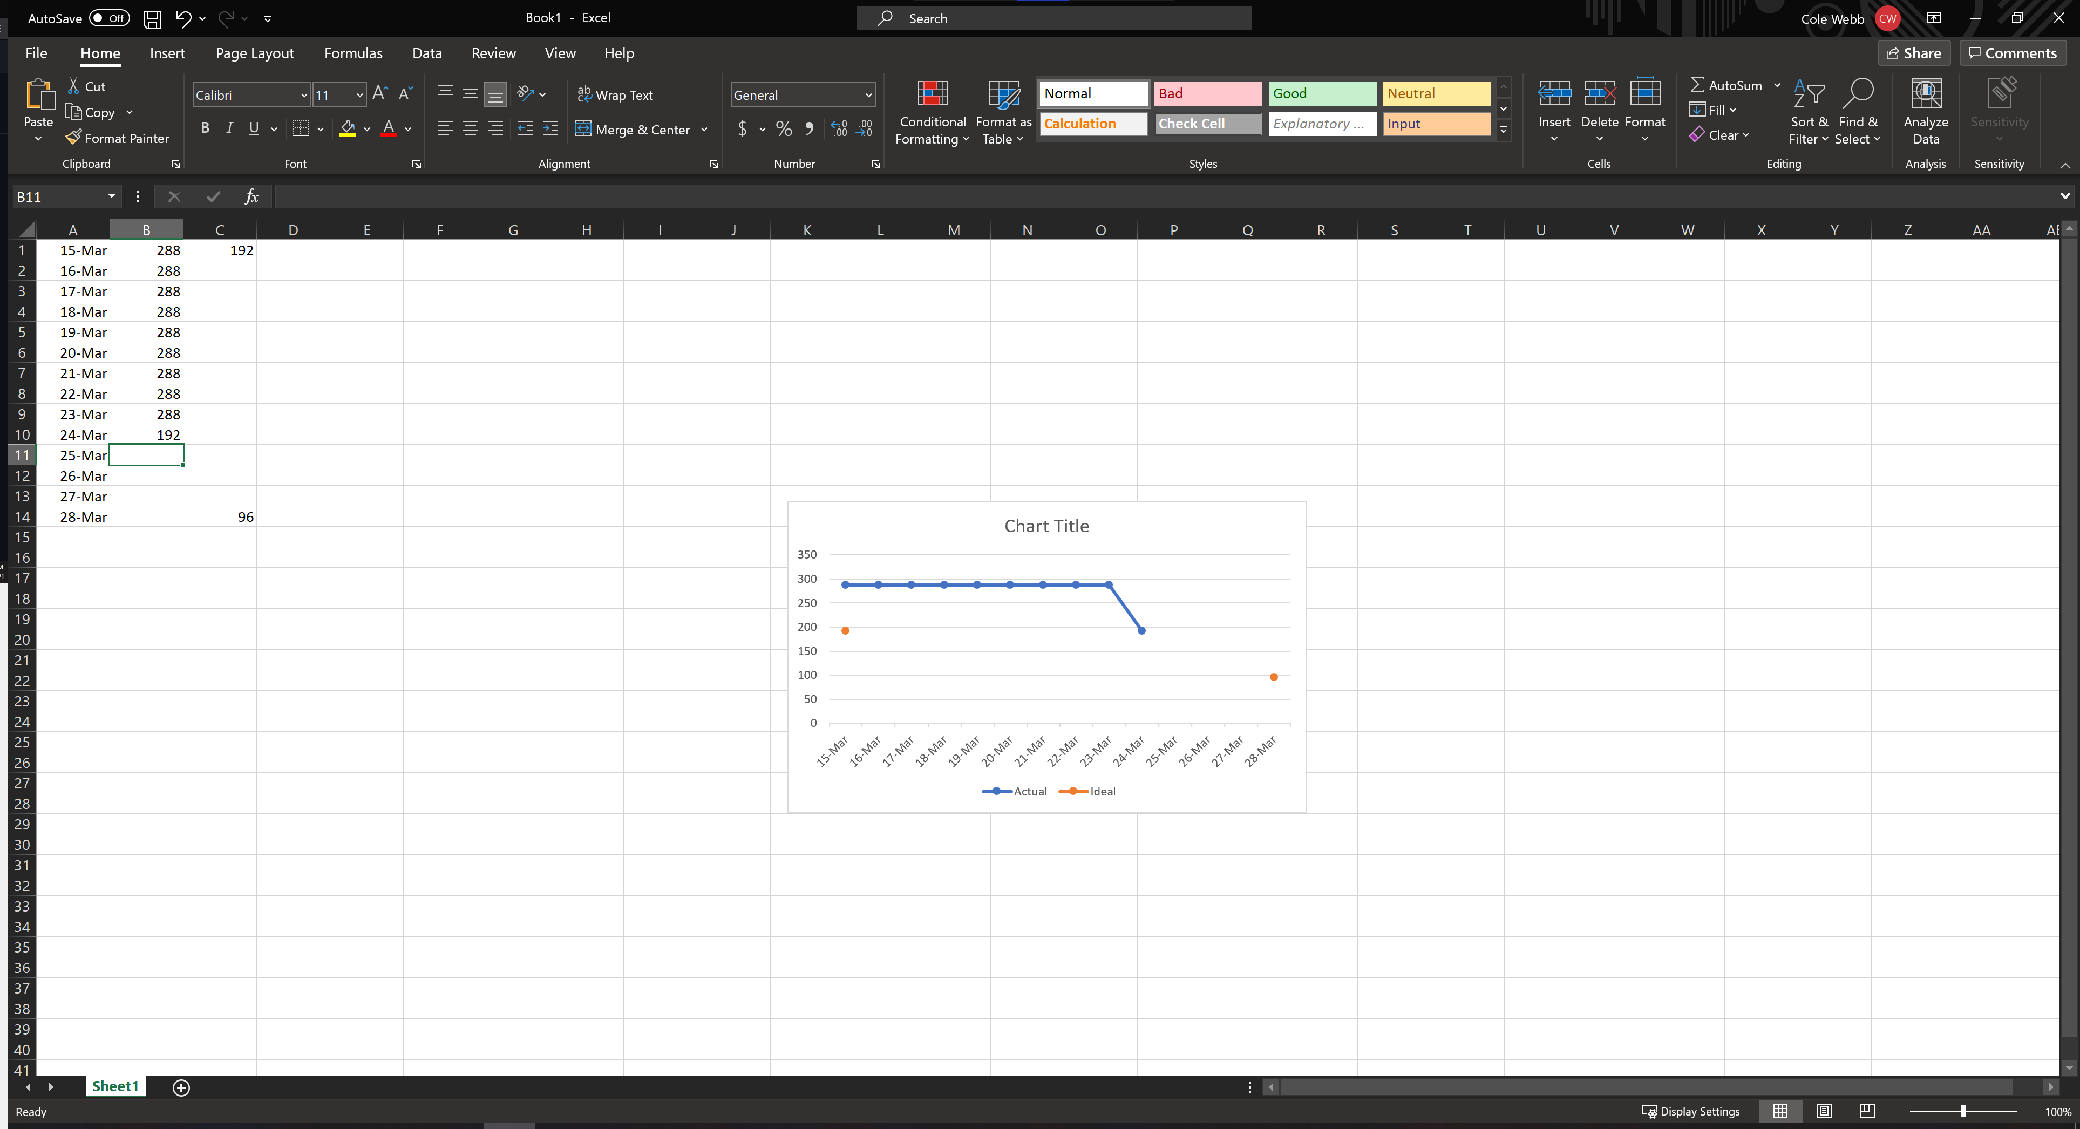

# Screenshot of you project board

